Name: Humza Ahmed

ID: IU04-0122-0041

Program: BSCS

Course: ADBMS

Faculty: Faraz Abdul Basit

Assignment 1 (ADBMS)
Insert 100 records into the tables of your project database.
After inserting the data, apply all possible wildcard searches on the table columns.
The wildcard patterns to be used include:
- %value
- value%
- %value%
- 1-5%
- ^1-5%
- _ (underscore using specific character)

Each table has 4–5 columns, and wildcards will be applied on each column.
Total queries = columns × Number of wildcard types × Number of tables
The overall limit is 300 queries, so choose No of tables According to this.

SQL CODE:

create database assign;
CREATE TABLE Patients (
PatientID INT PRIMARY KEY IDENTITY(1,1),
FirstName NVARCHAR(50) NOT NULL,
LastName NVARCHAR(50) NOT NULL,
Gender NVARCHAR(10),
DateOfBirth DATE,
PhoneNumber NVARCHAR(15),
Email NVARCHAR(100),
Address NVARCHAR(255),
BloodGroup NVARCHAR(5),
Status NVARCHAR(20) DEFAULT 'Active',
Created_at DATETIME DEFAULT GETDATE(),
Updated_at DATETIME DEFAULT GETDATE(),
Deleted_at DATETIME NULL,
Created_by NVARCHAR(50) DEFAULT 'System',
Updated_by NVARCHAR(50) DEFAULT 'System'
);

CREATE TABLE Doctors (
DoctorID INT PRIMARY KEY IDENTITY(1,1),
FirstName NVARCHAR(50) NOT NULL,
LastName NVARCHAR(50) NOT NULL,
Specialization NVARCHAR(100),
Qualification NVARCHAR(100),
ExperienceYears INT,
PhoneNumber NVARCHAR(15),
Email NVARCHAR(100),
ConsultationFee DECIMAL(10,2),
Status NVARCHAR(20) DEFAULT 'Active',
Created_at DATETIME DEFAULT GETDATE(),
Updated_at DATETIME DEFAULT GETDATE(),
Deleted_at DATETIME NULL,
Created_by NVARCHAR(50) DEFAULT 'System',
Updated_by NVARCHAR(50) DEFAULT 'System'
);

CREATE TABLE Departments (
DepartmentID INT PRIMARY KEY IDENTITY(1,1),
DepartmentName NVARCHAR(100) NOT NULL,
DepartmentCode NVARCHAR(10),
HeadDoctorID INT,
FloorNumber INT,
ContactNumber NVARCHAR(15),
Description NVARCHAR(500),
RoomCount INT,
Status NVARCHAR(20) DEFAULT 'Active',
Created_at DATETIME DEFAULT GETDATE(),
Updated_at DATETIME DEFAULT GETDATE(),
Deleted_at DATETIME NULL,
Created_by NVARCHAR(50) DEFAULT 'System',
Updated_by NVARCHAR(50) DEFAULT 'System'
);

CREATE TABLE Appointments (
AppointmentID INT PRIMARY KEY IDENTITY(1,1),
PatientID INT FOREIGN KEY REFERENCES Patients(PatientID),
DoctorID INT FOREIGN KEY REFERENCES Doctors(DoctorID),
AppointmentDate DATE,
AppointmentTime TIME,
Status NVARCHAR(20) DEFAULT 'Scheduled',
Reason NVARCHAR(255),
RoomNumber NVARCHAR(20),
FeesPaid DECIMAL(10,2),
Created_at DATETIME DEFAULT GETDATE(),
Updated_at DATETIME DEFAULT GETDATE(),
Deleted_at DATETIME NULL,
Created_by NVARCHAR(50) DEFAULT 'System',
Updated_by NVARCHAR(50) DEFAULT 'System'
);

CREATE TABLE Staff (
StaffID INT PRIMARY KEY IDENTITY(1,1),
FirstName NVARCHAR(50) NOT NULL,
LastName NVARCHAR(50) NOT NULL,
Designation NVARCHAR(100),
DepartmentID INT FOREIGN KEY REFERENCES Departments(DepartmentID),
HireDate DATE,
Salary DECIMAL(10,2),
PhoneNumber NVARCHAR(15),
Email NVARCHAR(100),
Status NVARCHAR(20) DEFAULT 'Active',
Created_at DATETIME DEFAULT GETDATE(),
Updated_at DATETIME DEFAULT GETDATE(),
Deleted_at DATETIME NULL,
Created_by NVARCHAR(50) DEFAULT 'System',
Updated_by NVARCHAR(50) DEFAULT 'System'
);

CREATE TABLE Medicines (
MedicineID INT PRIMARY KEY IDENTITY(1,1),
MedicineName NVARCHAR(100) NOT NULL,
Brand NVARCHAR(100),
Category NVARCHAR(50),
Price DECIMAL(10,2),
StockQuantity INT,
ExpiryDate DATE,
Manufacturer NVARCHAR(100),
Status NVARCHAR(20) DEFAULT 'Available',
Created_at DATETIME DEFAULT GETDATE(),
Updated_at DATETIME DEFAULT GETDATE(),
Deleted_at DATETIME NULL,
Created_by NVARCHAR(50) DEFAULT 'System',
Updated_by NVARCHAR(50) DEFAULT 'System'
);

CREATE TABLE Bills (
BillID INT PRIMARY KEY IDENTITY(1,1),
PatientID INT FOREIGN KEY REFERENCES Patients(PatientID),
BillDate DATE DEFAULT GETDATE(),
TotalAmount DECIMAL(12,2),
Discount DECIMAL(10,2),
TaxAmount DECIMAL(10,2),
PaidAmount DECIMAL(12,2),
PaymentMode NVARCHAR(50),
PaymentStatus NVARCHAR(20) DEFAULT 'Pending',
Status NVARCHAR(20) DEFAULT 'Active',
Created_at DATETIME DEFAULT GETDATE(),
Updated_at DATETIME DEFAULT GETDATE(),
Deleted_at DATETIME NULL,
Created_by NVARCHAR(50) DEFAULT 'System',
Updated_by NVARCHAR(50) DEFAULT 'System'
);

CREATE TABLE Rooms (
RoomID INT PRIMARY KEY IDENTITY(1,1),
RoomNumber NVARCHAR(20) NOT NULL,
RoomType NVARCHAR(50),
DepartmentID INT FOREIGN KEY REFERENCES Departments(DepartmentID),
FloorNumber INT,
BedCount INT,
Status NVARCHAR(20) DEFAULT 'Available',
ChargesPerDay DECIMAL(10,2),
Created_at DATETIME DEFAULT GETDATE(),
Updated_at DATETIME DEFAULT GETDATE(),
Deleted_at DATETIME NULL,
Created_by NVARCHAR(50) DEFAULT 'System',
Updated_by NVARCHAR(50) DEFAULT 'System'
);

CREATE TABLE Lab_Reports (
ReportID INT PRIMARY KEY IDENTITY(1,1),
PatientID INT FOREIGN KEY REFERENCES Patients(PatientID),
TestName NVARCHAR(100),
TestDate DATE DEFAULT GETDATE(),
Result NVARCHAR(MAX),
NormalRange NVARCHAR(100),
TestedBy NVARCHAR(100),
Remarks NVARCHAR(500),
Status NVARCHAR(20) DEFAULT 'Completed',
Created_at DATETIME DEFAULT GETDATE(),
Updated_at DATETIME DEFAULT GETDATE(),
Deleted_at DATETIME NULL,
Created_by NVARCHAR(50) DEFAULT 'System',
Updated_by NVARCHAR(50) DEFAULT 'System'
);

CREATE TABLE Prescriptions (
PrescriptionID INT PRIMARY KEY IDENTITY(1,1),
PatientID INT FOREIGN KEY REFERENCES Patients(PatientID),
DoctorID INT FOREIGN KEY REFERENCES Doctors(DoctorID),
PrescriptionDate DATE DEFAULT GETDATE(),
Diagnosis NVARCHAR(500),
MedicineDetails NVARCHAR(MAX),
Dosage NVARCHAR(100),
Duration NVARCHAR(50),
Status NVARCHAR(20) DEFAULT 'Active',
Created_at DATETIME DEFAULT GETDATE(),
Updated_at DATETIME DEFAULT GETDATE(),
Deleted_at DATETIME NULL,
Created_by NVARCHAR(50) DEFAULT 'System',
Updated_by NVARCHAR(50) DEFAULT 'System'
);

WITH Numbers AS (
SELECT TOP 100 ROW_NUMBER() OVER (ORDER BY (SELECT NULL)) AS n
FROM master.dbo.spt_values a
CROSS JOIN master.dbo.spt_values b
)
INSERT INTO Patients (FirstName, LastName, Gender, DateOfBirth, PhoneNumber, Email, Address, BloodGroup)
SELECT
'Patient' + CAST(n AS NVARCHAR(10)),
'LastName' + CAST(n AS NVARCHAR(10)),
CASE WHEN n % 2 = 0 THEN 'Female' ELSE 'Male' END,
DATEADD(YEAR, -20 - (n % 50), GETDATE()),
'98765' + RIGHT('00000' + CAST(n AS NVARCHAR(10)), 5),
'patient' + CAST(n AS NVARCHAR(10)) + '@email.com',
'Address ' + CAST(n AS NVARCHAR(10)) + ', City',
CASE (n % 8)
WHEN 0 THEN 'O+' WHEN 1 THEN 'A+' WHEN 2 THEN 'B+' WHEN 3 THEN 'AB+'
WHEN 4 THEN 'O-' WHEN 5 THEN 'A-' WHEN 6 THEN 'B-' ELSE 'AB-'
END
FROM Numbers;

WITH Numbers AS (
SELECT TOP 100 ROW_NUMBER() OVER (ORDER BY (SELECT NULL)) AS n
FROM master.dbo.spt_values
)
INSERT INTO Doctors (FirstName, LastName, Specialization, Qualification, ExperienceYears, PhoneNumber, Email, ConsultationFee)
SELECT
'Dr. Doctor' + CAST(n AS NVARCHAR(10)),
'LastName' + CAST(n AS NVARCHAR(10)),
CASE (n % 10)
WHEN 0 THEN 'Cardiology' WHEN 1 THEN 'Pediatrics' WHEN 2 THEN 'Orthopedics'
WHEN 3 THEN 'Gynecology' WHEN 4 THEN 'Neurology' WHEN 5 THEN 'Dermatology'
WHEN 6 THEN 'Oncology' WHEN 7 THEN 'Psychiatry' WHEN 8 THEN 'General Surgery' ELSE 'ENT'
END,
CASE (n % 4)
WHEN 0 THEN 'MD' WHEN 1 THEN 'MS' WHEN 2 THEN 'DM' ELSE 'DNB'
END + ' Qualification',
5 + (n % 25),
'98766' + RIGHT('00000' + CAST(n AS NVARCHAR(10)), 5),
'doctor' + CAST(n AS NVARCHAR(10)) + '@hospital.com',
1000 + (n % 1500)
FROM Numbers;
GO

WITH Numbers AS (
SELECT TOP 100 ROW_NUMBER() OVER (ORDER BY (SELECT NULL)) AS n
FROM master.dbo.spt_values
)
INSERT INTO Departments (DepartmentName, DepartmentCode, HeadDoctorID, FloorNumber, ContactNumber, Description, RoomCount)
SELECT
'Department ' + CAST(n AS NVARCHAR(10)),
'DEPT' + RIGHT('000' + CAST(n AS NVARCHAR(10)), 3),
1 + (n % 100),
1 + (n % 10),
'011-2345' + RIGHT('0000' + CAST(n AS NVARCHAR(10)), 4),
'Description for Department ' + CAST(n AS NVARCHAR(10)),
10 + (n % 40)
FROM Numbers;
GO

WITH Numbers AS (
SELECT TOP 100 ROW_NUMBER() OVER (ORDER BY (SELECT NULL)) AS n
FROM master.dbo.spt_values
)
INSERT INTO Appointments (PatientID, DoctorID, AppointmentDate, AppointmentTime, Status, Reason, RoomNumber, FeesPaid)
SELECT
1 + (n % 100),
1 + (n % 100),
DATEADD(DAY, n % 365, '2024-01-01'),
DATEADD(MINUTE, (n % 480) + 540, '00:00:00'),
CASE (n % 4)
WHEN 0 THEN 'Scheduled' WHEN 1 THEN 'Completed' WHEN 2 THEN 'Cancelled' ELSE 'No-Show'
END,
'Reason ' + CAST(n AS NVARCHAR(10)),
'Room-' + CAST(100 + (n % 400) AS NVARCHAR(10)),
(n % 5000)
FROM Numbers;
GO

WITH Numbers AS (
SELECT TOP 100 ROW_NUMBER() OVER (ORDER BY (SELECT NULL)) AS n
FROM master.dbo.spt_values
)
INSERT INTO Staff (FirstName, LastName, Designation, DepartmentID, HireDate, Salary, PhoneNumber, Email)
SELECT
'Staff' + CAST(n AS NVARCHAR(10)),
'LastName' + CAST(n AS NVARCHAR(10)),
CASE (n % 6)
WHEN 0 THEN 'Nurse' WHEN 1 THEN 'Receptionist' WHEN 2 THEN 'Lab Technician'
WHEN 3 THEN 'Pharmacist' WHEN 4 THEN 'Accountant' ELSE 'Administrator'
END,
1 + (n % 100),
DATEADD(DAY, - (n % 3650), GETDATE()),
20000 + (n % 40000),
'98767' + RIGHT('00000' + CAST(n AS NVARCHAR(10)), 5),
'staff' + CAST(n AS NVARCHAR(10)) + '@hospital.com'
FROM Numbers;
GO

WITH Numbers AS (
SELECT TOP 100 ROW_NUMBER() OVER (ORDER BY (SELECT NULL)) AS n
FROM master.dbo.spt_values
)
INSERT INTO Medicines (MedicineName, Brand, Category, Price, StockQuantity, ExpiryDate, Manufacturer)
SELECT
'Medicine ' + CAST(n AS NVARCHAR(10)),
CASE (n % 5)
WHEN 0 THEN 'BrandA' WHEN 1 THEN 'BrandB' WHEN 2 THEN 'BrandC' WHEN 3 THEN 'BrandD' ELSE 'BrandE'
END,
CASE (n % 4)
WHEN 0 THEN 'Tablet' WHEN 1 THEN 'Syrup' WHEN 2 THEN 'Injection' ELSE 'Capsule'
END,
10 + (n % 500),
50 + (n % 950),
DATEADD(DAY, 100 + (n % 1000), GETDATE()),
'Manufacturer ' + CAST(n % 10 AS NVARCHAR(10))
FROM Numbers;
GO

WITH Numbers AS (
SELECT TOP 100 ROW_NUMBER() OVER (ORDER BY (SELECT NULL)) AS n
FROM master.dbo.spt_values
)
INSERT INTO Bills (PatientID, BillDate, TotalAmount, Discount, TaxAmount, PaidAmount, PaymentMode, PaymentStatus)
SELECT
1 + (n % 100),
DATEADD(DAY, - (n % 180), GETDATE()),
1000 + (n % 10000),
(n % 500),
50 + (n % 300),
500 + (n % 9500),
CASE (n % 4)
WHEN 0 THEN 'Cash' WHEN 1 THEN 'Card' WHEN 2 THEN 'Insurance' ELSE 'Online'
END,
CASE (n % 3)
WHEN 0 THEN 'Paid' WHEN 1 THEN 'Pending' ELSE 'Partial'
END
FROM Numbers;
GO

WITH Numbers AS (
SELECT TOP 100 ROW_NUMBER() OVER (ORDER BY (SELECT NULL)) AS n
FROM master.dbo.spt_values
)
INSERT INTO Rooms (RoomNumber, RoomType, DepartmentID, FloorNumber, BedCount, Status, ChargesPerDay)
SELECT
'Room' + CAST(100 + n AS NVARCHAR(10)),
CASE (n % 4)
WHEN 0 THEN 'General' WHEN 1 THEN 'ICU' WHEN 2 THEN 'Private' ELSE 'Semi-Private'
END,
1 + (n % 100),
1 + (n % 10),
1 + (n % 5),
CASE (n % 3)
WHEN 0 THEN 'Available' WHEN 1 THEN 'Occupied' ELSE 'Maintenance'
END,
500 + (n % 4500)
FROM Numbers;
GO

WITH Numbers AS (
SELECT TOP 100 ROW_NUMBER() OVER (ORDER BY (SELECT NULL)) AS n
FROM master.dbo.spt_values
)
INSERT INTO Lab_Reports (PatientID, TestName, TestDate, Result, NormalRange, TestedBy, Remarks)
SELECT
1 + (n % 100),
CASE (n % 8)
WHEN 0 THEN 'Blood Test' WHEN 1 THEN 'X-Ray' WHEN 2 THEN 'MRI' WHEN 3 THEN 'CT Scan'
WHEN 4 THEN 'Urine Test' WHEN 5 THEN 'ECG' WHEN 6 THEN 'Ultrasound' ELSE 'Biopsy'
END,
DATEADD(DAY, - (n % 60), GETDATE()),
'Result ' + CAST(n AS NVARCHAR(10)),
'Normal Range ' + CAST(n % 10 AS NVARCHAR(10)),
'Technician ' + CAST(n % 20 AS NVARCHAR(10)),
'Remarks for test ' + CAST(n AS NVARCHAR(10))
FROM Numbers;
GO

WITH Numbers AS (
SELECT TOP 100 ROW_NUMBER() OVER (ORDER BY (SELECT NULL)) AS n
FROM master.dbo.spt_values
)
INSERT INTO Prescriptions (PatientID, DoctorID, PrescriptionDate, Diagnosis, MedicineDetails, Dosage, Duration)
SELECT
1 + (n % 100),
1 + (n % 100),
DATEADD(DAY, - (n % 30), GETDATE()),
'Diagnosis ' + CAST(n AS NVARCHAR(10)),
'Medicine details for prescription ' + CAST(n AS NVARCHAR(10)),
CASE (n % 3)
WHEN 0 THEN '1-1-1' WHEN 1 THEN '1-0-1' ELSE '0-0-1'
END,
CAST(7 + (n % 21) AS NVARCHAR(10)) + ' days'
FROM Numbers;
GO

PRINT '=== RECORD COUNT VERIFICATION ===';
SELECT 'Patients' AS TableName, COUNT(*) AS RecordCount FROM Patients
UNION ALL SELECT 'Doctors', COUNT(*) FROM Doctors
UNION ALL SELECT 'Departments', COUNT(*) FROM Departments
UNION ALL SELECT 'Appointments', COUNT(*) FROM Appointments
UNION ALL SELECT 'Staff', COUNT(*) FROM Staff
UNION ALL SELECT 'Medicines', COUNT(*) FROM Medicines
UNION ALL SELECT 'Bills', COUNT(*) FROM Bills
UNION ALL SELECT 'Rooms', COUNT(*) FROM Rooms
UNION ALL SELECT 'Lab_Reports', COUNT(*) FROM Lab_Reports
UNION ALL SELECT 'Prescriptions', COUNT(*) FROM Prescriptions;

SELECT * FROM Patients WHERE FirstName LIKE '%10';
SELECT * FROM Patients WHERE FirstName LIKE '%ent';
SELECT * FROM Patients WHERE FirstName LIKE 'Patient%';
SELECT * FROM Patients WHERE FirstName LIKE 'Pat%';
SELECT * FROM Patients WHERE FirstName LIKE '%tie%';
SELECT * FROM Patients WHERE FirstName LIKE '%ati%';
SELECT * FROM Patients WHERE FirstName LIKE '[1-5]%';
SELECT * FROM Patients WHERE FirstName LIKE '[^1-5]%';
SELECT * FROM Patients WHERE FirstName LIKE 'Patient_';
SELECT * FROM Patients WHERE FirstName LIKE 'Pat____%';

SELECT * FROM Patients WHERE LastName LIKE '%10';
SELECT * FROM Patients WHERE LastName LIKE 'LastName%';
SELECT * FROM Patients WHERE LastName LIKE '%Name%';
SELECT * FROM Patients WHERE LastName LIKE '[1-5]%';
SELECT * FROM Patients WHERE LastName LIKE '[^1-5]%';
SELECT * FROM Patients WHERE LastName LIKE 'LastName_';

SELECT * FROM Patients WHERE Gender LIKE '%le';
SELECT * FROM Patients WHERE Gender LIKE 'Fe%';
SELECT * FROM Patients WHERE Gender LIKE '%ale%';
SELECT * FROM Patients WHERE Gender LIKE '[FM]%';
SELECT * FROM Patients WHERE Gender LIKE '[^F]%';
SELECT * FROM Patients WHERE Gender LIKE 'M_le';

SELECT * FROM Patients WHERE Email LIKE '%.com';
SELECT * FROM Patients WHERE Email LIKE 'patient%';
SELECT * FROM Patients WHERE Email LIKE '%@%';
SELECT * FROM Patients WHERE Email LIKE '[1-5]%';
SELECT * FROM Patients WHERE Email LIKE '[^1-5]%';
SELECT * FROM Patients WHERE Email LIKE 'patient_%@%';

SELECT * FROM Patients WHERE PhoneNumber LIKE '%3210';
SELECT * FROM Patients WHERE PhoneNumber LIKE '98765%';
SELECT * FROM Patients WHERE PhoneNumber LIKE '%65%';
SELECT * FROM Patients WHERE PhoneNumber LIKE '[1-5]%';
SELECT * FROM Patients WHERE PhoneNumber LIKE '[^1-5]%';
SELECT * FROM Patients WHERE PhoneNumber LIKE '98765_____';

SELECT * FROM Patients WHERE BloodGroup LIKE '%+';
SELECT * FROM Patients WHERE BloodGroup LIKE 'A%';
SELECT * FROM Patients WHERE BloodGroup LIKE '%B%';
SELECT * FROM Patients WHERE BloodGroup LIKE '[AB]%';
SELECT * FROM Patients WHERE BloodGroup LIKE '[^A]%';
SELECT * FROM Patients WHERE BloodGroup LIKE '_+';

SELECT * FROM Patients WHERE Status LIKE '%ive';
SELECT * FROM Patients WHERE Status LIKE 'Act%';
SELECT * FROM Patients WHERE Status LIKE '%cti%';
SELECT * FROM Patients WHERE Status LIKE '[AI]%';
SELECT * FROM Patients WHERE Status LIKE '[^A]%';
SELECT * FROM Patients WHERE Status LIKE 'Ac___';

SELECT * FROM Doctors WHERE FirstName LIKE '[^1-5]%';
SELECT * FROM Doctors WHERE FirstName LIKE 'Dr. Doctor_';
SELECT * FROM Doctors WHERE Specialization LIKE '%logy';
SELECT * FROM Doctors WHERE Specialization LIKE 'Card%';
SELECT * FROM Doctors WHERE Specialization LIKE '%olo%';
SELECT * FROM Doctors WHERE Specialization LIKE '[C-N]%';
SELECT * FROM Doctors WHERE Specialization LIKE '[^C]%';
SELECT * FROM Doctors WHERE Specialization LIKE 'C_____ology';
SELECT * FROM Doctors WHERE Qualification LIKE '%tion';
SELECT * FROM Doctors WHERE Qualification LIKE 'MD%';
SELECT * FROM Doctors WHERE Qualification LIKE '%Qual%';
SELECT * FROM Doctors WHERE Qualification LIKE '[MD]%';
SELECT * FROM Doctors WHERE Qualification LIKE '[^M]%';
SELECT * FROM Doctors WHERE Qualification LIKE 'MD ________tion';
SELECT * FROM Doctors WHERE Email LIKE '%hospital.com';
SELECT * FROM Doctors WHERE Email LIKE 'doctor%';
SELECT * FROM Doctors WHERE Email LIKE '%@%';
SELECT * FROM Doctors WHERE Email LIKE '[1-5]%';
SELECT * FROM Doctors WHERE Email LIKE '[^1-5]%';
SELECT * FROM Doctors WHERE Email LIKE 'doctor_%@%';
SELECT * FROM Doctors WHERE CAST(ConsultationFee AS NVARCHAR(20)) LIKE '%00';
SELECT * FROM Doctors WHERE CAST(ConsultationFee AS NVARCHAR(20)) LIKE '1%';
SELECT * FROM Doctors WHERE CAST(ConsultationFee AS NVARCHAR(20)) LIKE '%50%';
SELECT * FROM Doctors WHERE CAST(ConsultationFee AS NVARCHAR(20)) LIKE '[1-2]%';
SELECT * FROM Doctors WHERE CAST(ConsultationFee AS NVARCHAR(20)) LIKE '[^1-2]%';
SELECT * FROM Doctors WHERE CAST(ConsultationFee AS NVARCHAR(20)) LIKE '__00';
SELECT * FROM Doctors WHERE PhoneNumber LIKE '%0001';
SELECT * FROM Doctors WHERE PhoneNumber LIKE '98766%';
SELECT * FROM Doctors WHERE PhoneNumber LIKE '%66%';
SELECT * FROM Doctors WHERE PhoneNumber LIKE '[1-5]%';
SELECT * FROM Doctors WHERE PhoneNumber LIKE '[^1-5]%';
SELECT * FROM Doctors WHERE PhoneNumber LIKE '98766_____';
SELECT * FROM Doctors WHERE Status LIKE '%ive';
SELECT * FROM Doctors WHERE Status LIKE 'Act%';
SELECT * FROM Doctors WHERE Status LIKE '%cti%';
SELECT * FROM Doctors WHERE Status LIKE '[AI]%';
SELECT * FROM Doctors WHERE Status LIKE '[^A]%';
SELECT * FROM Doctors WHERE Status LIKE 'Ac___';

SELECT * FROM Appointments WHERE Status LIKE '%ed';
SELECT * FROM Appointments WHERE Status LIKE 'Sch%';
SELECT * FROM Appointments WHERE Status LIKE '%edul%';
SELECT * FROM Appointments WHERE Status LIKE '[SC]%';
SELECT * FROM Appointments WHERE Status LIKE '[^S]%';
SELECT * FROM Appointments WHERE Status LIKE 'S_____ed';
SELECT * FROM Appointments WHERE Reason LIKE '%10';
SELECT * FROM Appointments WHERE Reason LIKE 'Reason%';
SELECT * FROM Appointments WHERE Reason LIKE '%son%';
SELECT * FROM Appointments WHERE Reason LIKE '[1-5]%';
SELECT * FROM Appointments WHERE Reason LIKE '[^1-5]%';
SELECT * FROM Appointments WHERE Reason LIKE 'Reason_';
SELECT * FROM Appointments WHERE RoomNumber LIKE '%01';
SELECT * FROM Appointments WHERE RoomNumber LIKE 'Room%';
SELECT * FROM Appointments WHERE RoomNumber LIKE '%om%';
SELECT * FROM Appointments WHERE RoomNumber LIKE '[1-5]%';
SELECT * FROM Appointments WHERE RoomNumber LIKE '[^1-5]%';
SELECT * FROM Appointments WHERE RoomNumber LIKE 'Room-___';
SELECT * FROM Appointments WHERE CONVERT(NVARCHAR, AppointmentDate, 23) LIKE '2024%';
SELECT * FROM Appointments WHERE CONVERT(NVARCHAR, AppointmentDate, 23) LIKE '%01%';
SELECT * FROM Appointments WHERE CONVERT(NVARCHAR, AppointmentDate, 23) LIKE '%2024%';
SELECT * FROM Appointments WHERE CONVERT(NVARCHAR, AppointmentDate, 23) LIKE '2024-01%';
SELECT * FROM Appointments WHERE CONVERT(NVARCHAR, AppointmentDate, 23) LIKE '2024-[0-1]%';
SELECT * FROM Appointments WHERE CONVERT(NVARCHAR, AppointmentDate, 23) LIKE '2024-0_-%';
SELECT * FROM Appointments WHERE CONVERT(NVARCHAR, AppointmentTime, 8) LIKE '%:00';
SELECT * FROM Appointments WHERE CONVERT(NVARCHAR, AppointmentTime, 8) LIKE '10%';
SELECT * FROM Appointments WHERE CONVERT(NVARCHAR, AppointmentTime, 8) LIKE '%:3%';
SELECT * FROM Appointments WHERE CONVERT(NVARCHAR, AppointmentTime, 8) LIKE '[0-1]%';
SELECT * FROM Appointments WHERE CONVERT(NVARCHAR, AppointmentTime, 8) LIKE '[^0-1]%';
SELECT * FROM Appointments WHERE CONVERT(NVARCHAR, AppointmentTime, 8) LIKE '__:__:00';
SELECT * FROM Appointments WHERE CAST(FeesPaid AS NVARCHAR(20)) LIKE '%0';
SELECT * FROM Appointments WHERE CAST(FeesPaid AS NVARCHAR(20)) LIKE '1%';
SELECT * FROM Appointments WHERE CAST(FeesPaid AS NVARCHAR(20)) LIKE '%00%';
SELECT * FROM Appointments WHERE CAST(FeesPaid AS NVARCHAR(20)) LIKE '[0-2]%';
SELECT * FROM Appointments WHERE CAST(FeesPaid AS NVARCHAR(20)) LIKE '[^0-2]%';
SELECT * FROM Appointments WHERE CAST(FeesPaid AS NVARCHAR(20)) LIKE '___0';
SELECT * FROM Appointments WHERE CONVERT(NVARCHAR, Created_at, 120) LIKE '%00';
SELECT * FROM Appointments WHERE CONVERT(NVARCHAR, Created_at, 120) LIKE '202%';
SELECT * FROM Appointments WHERE CONVERT(NVARCHAR, Created_at, 120) LIKE '%-%';
SELECT * FROM Appointments WHERE CONVERT(NVARCHAR, Created_at, 120) LIKE '202[0-9]%';
SELECT * FROM Appointments WHERE CONVERT(NVARCHAR, Created_at, 120) LIKE '[^2]%';
SELECT * FROM Appointments WHERE CONVERT(NVARCHAR, Created_at, 120) LIKE '202_-__-__%';

SELECT * FROM Staff WHERE FirstName LIKE '%10';
SELECT * FROM Staff WHERE FirstName LIKE 'Staff%';
SELECT * FROM Staff WHERE FirstName LIKE '%taf%';
SELECT * FROM Staff WHERE FirstName LIKE '[1-5]%';
SELECT * FROM Staff WHERE FirstName LIKE '[^1-5]%';
SELECT * FROM Staff WHERE FirstName LIKE 'Staff_';
SELECT * FROM Staff WHERE LastName LIKE '%10';
SELECT * FROM Staff WHERE LastName LIKE 'LastName%';
SELECT * FROM Staff WHERE LastName LIKE '%Name%';
SELECT * FROM Staff WHERE LastName LIKE '[1-5]%';
SELECT * FROM Staff WHERE LastName LIKE '[^1-5]%';
SELECT * FROM Staff WHERE LastName LIKE 'LastName_';
SELECT * FROM Staff WHERE Designation LIKE '%ist';
SELECT * FROM Staff WHERE Designation LIKE 'Nur%';
SELECT * FROM Staff WHERE Designation LIKE '%ech%';
SELECT * FROM Staff WHERE Designation LIKE '[AN]%';
SELECT * FROM Staff WHERE Designation LIKE '[^N]%';
SELECT * FROM Staff WHERE Designation LIKE 'N__se';
SELECT * FROM Staff WHERE Email LIKE '%hospital.com';
SELECT * FROM Staff WHERE Email LIKE 'staff%';
SELECT * FROM Staff WHERE Email LIKE '%@%';
SELECT * FROM Staff WHERE Email LIKE '[1-5]%';
SELECT * FROM Staff WHERE Email LIKE '[^1-5]%';
SELECT * FROM Staff WHERE Email LIKE 'staff_%@%';
SELECT * FROM Staff WHERE PhoneNumber LIKE '%0001';
SELECT * FROM Staff WHERE PhoneNumber LIKE '98767%';
SELECT * FROM Staff WHERE PhoneNumber LIKE '%67%';
SELECT * FROM Staff WHERE PhoneNumber LIKE '[1-5]%';
SELECT * FROM Staff WHERE PhoneNumber LIKE '[^1-5]%';
SELECT * FROM Staff WHERE PhoneNumber LIKE '98767_____';
SELECT * FROM Staff WHERE CAST(Salary AS NVARCHAR(20)) LIKE '%000';
SELECT * FROM Staff WHERE CAST(Salary AS NVARCHAR(20)) LIKE '2%';
SELECT * FROM Staff WHERE CAST(Salary AS NVARCHAR(20)) LIKE '%00%';
SELECT * FROM Staff WHERE CAST(Salary AS NVARCHAR(20)) LIKE '[2-4]%';
SELECT * FROM Staff WHERE CAST(Salary AS NVARCHAR(20)) LIKE '[^2-4]%';
SELECT * FROM Staff WHERE CAST(Salary AS NVARCHAR(20)) LIKE '__000';
SELECT * FROM Staff WHERE Status LIKE '%ive';
SELECT * FROM Staff WHERE Status LIKE 'Act%';
SELECT * FROM Staff WHERE Status LIKE '%cti%';
SELECT * FROM Staff WHERE Status LIKE '[AI]%';
SELECT * FROM Staff WHERE Status LIKE '[^A]%';
SELECT * FROM Staff WHERE Status LIKE 'Ac___';

SELECT * FROM Medicines WHERE MedicineName LIKE '%10';
SELECT * FROM Medicines WHERE MedicineName LIKE 'Medicine%';
SELECT * FROM Medicines WHERE MedicineName LIKE '%edi%';
SELECT * FROM Medicines WHERE MedicineName LIKE '[1-5]%';
SELECT * FROM Medicines WHERE MedicineName LIKE '[^1-5]%';
SELECT * FROM Medicines WHERE MedicineName LIKE 'Medicine_';
SELECT * FROM Medicines WHERE Brand LIKE '%A';
SELECT * FROM Medicines WHERE Brand LIKE 'Brand%';
SELECT * FROM Medicines WHERE Brand LIKE '%and%';
SELECT * FROM Medicines WHERE Brand LIKE '[AB]%';
SELECT * FROM Medicines WHERE Brand LIKE '[^B]%';
SELECT * FROM Medicines WHERE Brand LIKE 'Brand_';
SELECT * FROM Medicines WHERE Category LIKE '%et';
SELECT * FROM Medicines WHERE Category LIKE 'Tab%';
SELECT * FROM Medicines WHERE Category LIKE '%ru%';
SELECT * FROM Medicines WHERE Category LIKE '[TS]%';
SELECT * FROM Medicines WHERE Category LIKE '[^T]%';
SELECT * FROM Medicines WHERE Category LIKE 'T__let';
SELECT * FROM Medicines WHERE CAST(Price AS NVARCHAR(20)) LIKE '%0';
SELECT * FROM Medicines WHERE CAST(Price AS NVARCHAR(20)) LIKE '1%';
SELECT * FROM Medicines WHERE CAST(Price AS NVARCHAR(20)) LIKE '%5%';
SELECT * FROM Medicines WHERE CAST(Price AS NVARCHAR(20)) LIKE '[1-3]%';
SELECT * FROM Medicines WHERE CAST(Price AS NVARCHAR(20)) LIKE '[^1-3]%';
SELECT * FROM Medicines WHERE CAST(Price AS NVARCHAR(20)) LIKE '___';
SELECT * FROM Medicines WHERE CAST(StockQuantity AS NVARCHAR(20)) LIKE '%0';
SELECT * FROM Medicines WHERE CAST(StockQuantity AS NVARCHAR(20)) LIKE '5%';
SELECT * FROM Medicines WHERE CAST(StockQuantity AS NVARCHAR(20)) LIKE '%9%';
SELECT * FROM Medicines WHERE CAST(StockQuantity AS NVARCHAR(20)) LIKE '[5-7]%';
SELECT * FROM Medicines WHERE CAST(StockQuantity AS NVARCHAR(20)) LIKE '[^5-7]%';
SELECT * FROM Medicines WHERE CAST(StockQuantity AS NVARCHAR(20)) LIKE '___';
SELECT * FROM Medicines WHERE Manufacturer LIKE '%0';
SELECT * FROM Medicines WHERE Manufacturer LIKE 'Manufacturer%';
SELECT * FROM Medicines WHERE Manufacturer LIKE '%act%';
SELECT * FROM Medicines WHERE Manufacturer LIKE '[1-5]%';
SELECT * FROM Medicines WHERE Manufacturer LIKE '[^1-5]%';
SELECT * FROM Medicines WHERE Manufacturer LIKE 'Manufacturer_';
SELECT * FROM Medicines WHERE Status LIKE '%able';
SELECT * FROM Medicines WHERE Status LIKE 'Avail%';
SELECT * FROM Medicines WHERE Status LIKE '%ail%';
SELECT * FROM Medicines WHERE Status LIKE '[AU]%';
SELECT * FROM Medicines WHERE Status LIKE '[^A]%';
SELECT * FROM Medicines WHERE Status LIKE 'Av___';

SELECT * FROM Bills WHERE PaymentMode LIKE '%sh';
SELECT * FROM Bills WHERE PaymentMode LIKE 'Ca%';
SELECT * FROM Bills WHERE PaymentMode LIKE '%rd%';
SELECT * FROM Bills WHERE PaymentMode LIKE '[CI]%';
SELECT * FROM Bills WHERE PaymentMode LIKE '[^C]%';
SELECT * FROM Bills WHERE PaymentMode LIKE 'C__h';
SELECT * FROM Bills WHERE PaymentStatus LIKE '%id';
SELECT * FROM Bills WHERE PaymentStatus LIKE 'Pa%';
SELECT * FROM Bills WHERE PaymentStatus LIKE '%en%';
SELECT * FROM Bills WHERE PaymentStatus LIKE '[PP]%';
SELECT * FROM Bills WHERE PaymentStatus LIKE '[^P]%';
SELECT * FROM Bills WHERE PaymentStatus LIKE 'P__d';
SELECT * FROM Bills WHERE CONVERT(NVARCHAR, BillDate, 23) LIKE '%30';
SELECT * FROM Bills WHERE CONVERT(NVARCHAR, BillDate, 23) LIKE '202%';
SELECT * FROM Bills WHERE CONVERT(NVARCHAR, BillDate, 23) LIKE '%-%';
SELECT * FROM Bills WHERE CONVERT(NVARCHAR, BillDate, 23) LIKE '202[0-9]%';
SELECT * FROM Bills WHERE CONVERT(NVARCHAR, BillDate, 23) LIKE '[^2]%';
SELECT * FROM Bills WHERE CONVERT(NVARCHAR, BillDate, 23) LIKE '202_-__-__';
SELECT * FROM Bills WHERE CAST(TotalAmount AS NVARCHAR(20)) LIKE '%00';
SELECT * FROM Bills WHERE CAST(TotalAmount AS NVARCHAR(20)) LIKE '1%';
SELECT * FROM Bills WHERE CAST(TotalAmount AS NVARCHAR(20)) LIKE '%00%';
SELECT * FROM Bills WHERE CAST(TotalAmount AS NVARCHAR(20)) LIKE '[1-5]%';
SELECT * FROM Bills WHERE CAST(TotalAmount AS NVARCHAR(20)) LIKE '[^1-5]%';
SELECT * FROM Bills WHERE CAST(TotalAmount AS NVARCHAR(20)) LIKE '____';
SELECT * FROM Bills WHERE CAST(Discount AS NVARCHAR(20)) LIKE '%0';
SELECT * FROM Bills WHERE CAST(Discount AS NVARCHAR(20)) LIKE '1%';
SELECT * FROM Bills WHERE CAST(Discount AS NVARCHAR(20)) LIKE '%5%';
SELECT * FROM Bills WHERE CAST(Discount AS NVARCHAR(20)) LIKE '[0-2]%';
SELECT * FROM Bills WHERE CAST(Discount AS NVARCHAR(20)) LIKE '[^0-2]%';
SELECT * FROM Bills WHERE CAST(Discount AS NVARCHAR(20)) LIKE '___';
SELECT * FROM Bills WHERE CAST(PaidAmount AS NVARCHAR(20)) LIKE '%00';
SELECT * FROM Bills WHERE CAST(PaidAmount AS NVARCHAR(20)) LIKE '5%';
SELECT * FROM Bills WHERE CAST(PaidAmount AS NVARCHAR(20)) LIKE '%00%';
SELECT * FROM Bills WHERE CAST(PaidAmount AS NVARCHAR(20)) LIKE '[5-7]%';
SELECT * FROM Bills WHERE CAST(PaidAmount AS NVARCHAR(20)) LIKE '[^5-7]%';
SELECT * FROM Bills WHERE CAST(PaidAmount AS NVARCHAR(20)) LIKE '____';
SELECT * FROM Bills WHERE Status LIKE '%ive';
SELECT * FROM Bills WHERE Status LIKE 'Act%';
SELECT * FROM Bills WHERE Status LIKE '%cti%';
SELECT * FROM Bills WHERE Status LIKE '[AI]%';
SELECT * FROM Bills WHERE Status LIKE '[^A]%';
SELECT * FROM Bills WHERE Status LIKE 'Ac___';

SELECT * FROM Rooms WHERE RoomNumber LIKE '%01';
SELECT * FROM Rooms WHERE RoomNumber LIKE 'Room%';
SELECT * FROM Rooms WHERE RoomNumber LIKE '%om%';
SELECT * FROM Rooms WHERE RoomNumber LIKE '[1-2]%';
SELECT * FROM Rooms WHERE RoomNumber LIKE '[^1-2]%';
SELECT * FROM Rooms WHERE RoomNumber LIKE 'Room___';
SELECT * FROM Rooms WHERE RoomType LIKE '%ral';
SELECT * FROM Rooms WHERE RoomType LIKE 'Gen%';
SELECT * FROM Rooms WHERE RoomType LIKE '%iva%';
SELECT * FROM Rooms WHERE RoomType LIKE '[GI]%';
SELECT * FROM Rooms WHERE RoomType LIKE '[^G]%';
SELECT * FROM Rooms WHERE RoomType LIKE 'G__eral';
SELECT * FROM Rooms WHERE CAST(FloorNumber AS NVARCHAR(10)) LIKE '%1';
SELECT * FROM Rooms WHERE CAST(FloorNumber AS NVARCHAR(10)) LIKE '1%';
SELECT * FROM Rooms WHERE CAST(FloorNumber AS NVARCHAR(10)) LIKE '%2%';
SELECT * FROM Rooms WHERE CAST(FloorNumber AS NVARCHAR(10)) LIKE '[1-3]%';
SELECT * FROM Rooms WHERE CAST(FloorNumber AS NVARCHAR(10)) LIKE '[^1-3]%';
SELECT * FROM Rooms WHERE CAST(FloorNumber AS NVARCHAR(10)) LIKE '_';
SELECT * FROM Rooms WHERE CAST(BedCount AS NVARCHAR(10)) LIKE '%1';
SELECT * FROM Rooms WHERE CAST(BedCount AS NVARCHAR(10)) LIKE '1%';
SELECT * FROM Rooms WHERE CAST(BedCount AS NVARCHAR(10)) LIKE '%3%';
SELECT * FROM Rooms WHERE CAST(BedCount AS NVARCHAR(10)) LIKE '[1-3]%';
SELECT * FROM Rooms WHERE CAST(BedCount AS NVARCHAR(10)) LIKE '[^1-3]%';
SELECT * FROM Rooms WHERE CAST(BedCount AS NVARCHAR(10)) LIKE '_';
SELECT * FROM Rooms WHERE Status LIKE '%ble';
SELECT * FROM Rooms WHERE Status LIKE 'Ava%';
SELECT * FROM Rooms WHERE Status LIKE '%upa%';
SELECT * FROM Rooms WHERE Status LIKE '[AM]%';
SELECT * FROM Rooms WHERE Status LIKE '[^A]%';
SELECT * FROM Rooms WHERE Status LIKE 'Ava___';
SELECT * FROM Rooms WHERE CAST(ChargesPerDay AS NVARCHAR(20)) LIKE '%00';
SELECT * FROM Rooms WHERE CAST(ChargesPerDay AS NVARCHAR(20)) LIKE '5%';
SELECT * FROM Rooms WHERE CAST(ChargesPerDay AS NVARCHAR(20)) LIKE '%00%';
SELECT * FROM Rooms WHERE CAST(ChargesPerDay AS NVARCHAR(20)) LIKE '[5-9]%';
SELECT * FROM Rooms WHERE CAST(ChargesPerDay AS NVARCHAR(20)) LIKE '[^5-9]%';
SELECT * FROM Rooms WHERE CAST(ChargesPerDay AS NVARCHAR(20)) LIKE '____';
SELECT * FROM Rooms WHERE CONVERT(NVARCHAR, Created_at, 120) LIKE '%00';
SELECT * FROM Rooms WHERE CONVERT(NVARCHAR, Created_at, 120) LIKE '202%';
SELECT * FROM Rooms WHERE CONVERT(NVARCHAR, Created_at, 120) LIKE '%-%';
SELECT * FROM Rooms WHERE CONVERT(NVARCHAR, Created_at, 120) LIKE '202[0-9]%';
SELECT * FROM Rooms WHERE CONVERT(NVARCHAR, Created_at, 120) LIKE '[^2]%';
SELECT * FROM Rooms WHERE CONVERT(NVARCHAR, Created_at, 120) LIKE '202_-__-__%';

SELECT * FROM Departments WHERE DepartmentName LIKE '%10';
SELECT * FROM Departments WHERE DepartmentName LIKE 'Department%';
SELECT * FROM Departments WHERE DepartmentName LIKE '%part%';
SELECT * FROM Departments WHERE DepartmentName LIKE '[1-5]%';
SELECT * FROM Departments WHERE DepartmentName LIKE '[^1-5]%';
SELECT * FROM Departments WHERE DepartmentName LIKE 'Department_';

SELECT * FROM Departments WHERE DepartmentCode LIKE '%T01';
SELECT * FROM Departments WHERE DepartmentCode LIKE 'DEPT%';
SELECT * FROM Departments WHERE DepartmentCode LIKE '%EP%';
SELECT * FROM Departments WHERE DepartmentCode LIKE '[A-D]%';
SELECT * FROM Departments WHERE DepartmentCode LIKE '[^D]%';
SELECT * FROM Departments WHERE DepartmentCode LIKE 'DEPT___';

SELECT * FROM Departments WHERE CAST(FloorNumber AS NVARCHAR(10)) LIKE '%1';
SELECT * FROM Departments WHERE CAST(FloorNumber AS NVARCHAR(10)) LIKE '1%';
SELECT * FROM Departments WHERE CAST(FloorNumber AS NVARCHAR(10)) LIKE '%2%';
SELECT * FROM Departments WHERE CAST(FloorNumber AS NVARCHAR(10)) LIKE '[1-3]%';
SELECT * FROM Departments WHERE CAST(FloorNumber AS NVARCHAR(10)) LIKE '[^1-3]%';
SELECT * FROM Departments WHERE CAST(FloorNumber AS NVARCHAR(10)) LIKE '_';

SELECT * FROM Departments WHERE ContactNumber LIKE '%0001';
SELECT * FROM Departments WHERE ContactNumber LIKE '011%';
SELECT * FROM Departments WHERE ContactNumber LIKE '%2345%';
SELECT * FROM Departments WHERE ContactNumber LIKE '[0-1]%';
SELECT * FROM Departments WHERE ContactNumber LIKE '[^0-1]%';
SELECT * FROM Departments WHERE ContactNumber LIKE '011-2345____';

SELECT * FROM Departments WHERE Status LIKE '%ive';
SELECT * FROM Departments WHERE Status LIKE 'Act%';
SELECT * FROM Departments WHERE Status LIKE '%cti%';
SELECT * FROM Departments WHERE Status LIKE '[AI]%';
SELECT * FROM Departments WHERE Status LIKE '[^A]%';
SELECT * FROM Departments WHERE Status LIKE 'Ac___';

SELECT * FROM Lab_Reports WHERE TestName LIKE '%Test';
SELECT * FROM Lab_Reports WHERE TestName LIKE 'Blood%';
SELECT * FROM Lab_Reports WHERE TestName LIKE '%ood%';
SELECT * FROM Lab_Reports WHERE TestName LIKE '[B-X]%';
SELECT * FROM Lab_Reports WHERE TestName LIKE '[^B]%';
SELECT * FROM Lab_Reports WHERE TestName LIKE 'B_____Test';

SELECT * FROM Lab_Reports WHERE Result LIKE '%10';
SELECT * FROM Lab_Reports WHERE Result LIKE 'Result%';
SELECT * FROM Lab_Reports WHERE Result LIKE '%sul%';
SELECT * FROM Lab_Reports WHERE Result LIKE '[1-5]%';
SELECT * FROM Lab_Reports WHERE Result LIKE '[^1-5]%';
SELECT * FROM Lab_Reports WHERE Result LIKE 'Result_';

SELECT * FROM Lab_Reports WHERE NormalRange LIKE '%10';
SELECT * FROM Lab_Reports WHERE NormalRange LIKE 'Normal%';
SELECT * FROM Lab_Reports WHERE NormalRange LIKE '%mal%';
SELECT * FROM Lab_Reports WHERE NormalRange LIKE '[1-5]%';
SELECT * FROM Lab_Reports WHERE NormalRange LIKE '[^1-5]%';
SELECT * FROM Lab_Reports WHERE NormalRange LIKE 'Normal Range_';

SELECT * FROM Lab_Reports WHERE TestedBy LIKE '%10';
SELECT * FROM Lab_Reports WHERE TestedBy LIKE 'Technician%';
SELECT * FROM Lab_Reports WHERE TestedBy LIKE '%ech%';
SELECT * FROM Lab_Reports WHERE TestedBy LIKE '[1-5]%';
SELECT * FROM Lab_Reports WHERE TestedBy LIKE '[^1-5]%';
SELECT * FROM Lab_Reports WHERE TestedBy LIKE 'Technician_';

SELECT * FROM Lab_Reports WHERE Status LIKE '%ed';
SELECT * FROM Lab_Reports WHERE Status LIKE 'Comp%';
SELECT * FROM Lab_Reports WHERE Status LIKE '%let%';
SELECT * FROM Lab_Reports WHERE Status LIKE '[CP]%';
SELECT * FROM Lab_Reports WHERE Status LIKE '[^C]%';
SELECT * FROM Lab_Reports WHERE Status LIKE 'Com_____ed';

SELECT * FROM Prescriptions WHERE Diagnosis LIKE '%10';
SELECT * FROM Prescriptions WHERE Diagnosis LIKE 'Diagnosis%';
SELECT * FROM Prescriptions WHERE Diagnosis LIKE '%nos%';
SELECT * FROM Prescriptions WHERE Diagnosis LIKE '[1-5]%';
SELECT * FROM Prescriptions WHERE Diagnosis LIKE '[^1-5]%';
SELECT * FROM Prescriptions WHERE Diagnosis LIKE 'Diagnosis_';

SELECT * FROM Prescriptions WHERE MedicineDetails LIKE '%10';
SELECT * FROM Prescriptions WHERE MedicineDetails LIKE 'Medicine%';
SELECT * FROM Prescriptions WHERE MedicineDetails LIKE '%edi%';
SELECT * FROM Prescriptions WHERE MedicineDetails LIKE '[1-5]%';
SELECT * FROM Prescriptions WHERE MedicineDetails LIKE '[^1-5]%';
SELECT * FROM Prescriptions WHERE MedicineDetails LIKE 'Medicine details for prescription_';

SELECT * FROM Prescriptions WHERE Dosage LIKE '%1';
SELECT * FROM Prescriptions WHERE Dosage LIKE '1%';
SELECT * FROM Prescriptions WHERE Dosage LIKE '%-%';
SELECT * FROM Prescriptions WHERE Dosage LIKE '[0-1]%';
SELECT * FROM Prescriptions WHERE Dosage LIKE '[^0-1]%';
SELECT * FROM Prescriptions WHERE Dosage LIKE '_-_-_';

SELECT * FROM Prescriptions WHERE Duration LIKE '%days';
SELECT * FROM Prescriptions WHERE Duration LIKE '7%';
SELECT * FROM Prescriptions WHERE Duration LIKE '%ay%';
SELECT * FROM Prescriptions WHERE Duration LIKE '[0-9]%';
SELECT * FROM Prescriptions WHERE Duration LIKE '[^0-9]%';
SELECT * FROM Prescriptions WHERE Duration LIKE '__ days';

SELECT * FROM Prescriptions WHERE Status LIKE '%ive';
SELECT * FROM Prescriptions WHERE Status LIKE 'Act%';
SELECT * FROM Prescriptions WHERE Status LIKE '%cti%';
SELECT * FROM Prescriptions WHERE Status LIKE '[AI]%';
SELECT * FROM Prescriptions WHERE Status LIKE '[^A]%';
SELECT * FROM Prescriptions WHERE Status LIKE 'Ac___';

Code Screen Shot/Output:

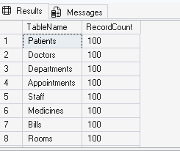
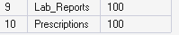

Patients:
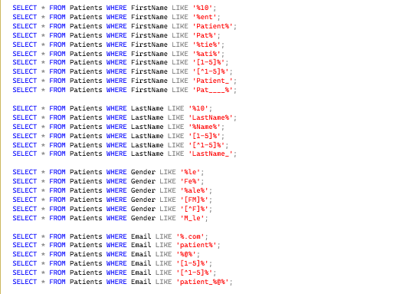
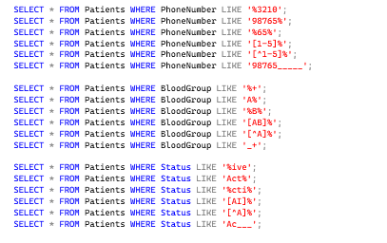
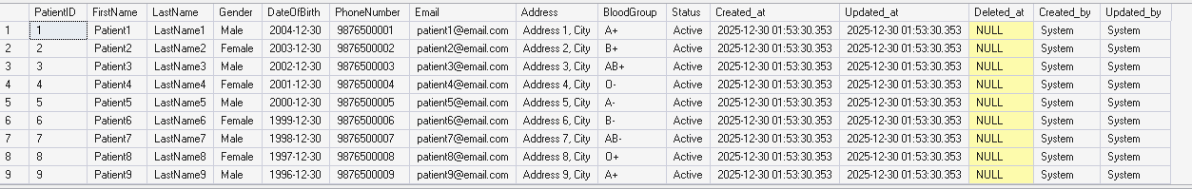

Doctors:
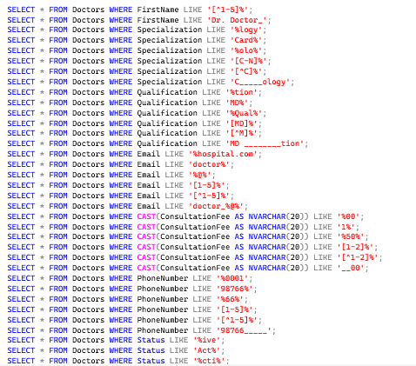
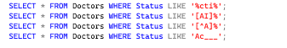
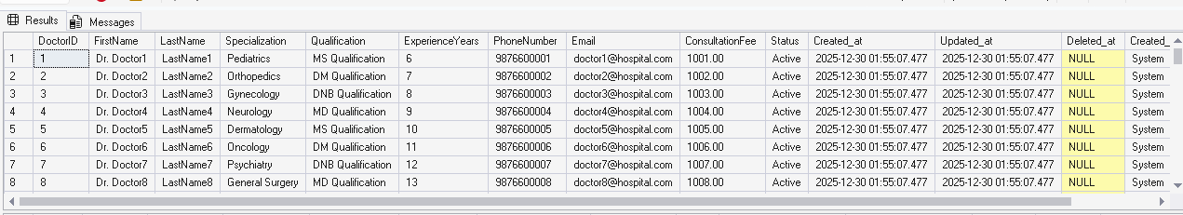

Appointments:
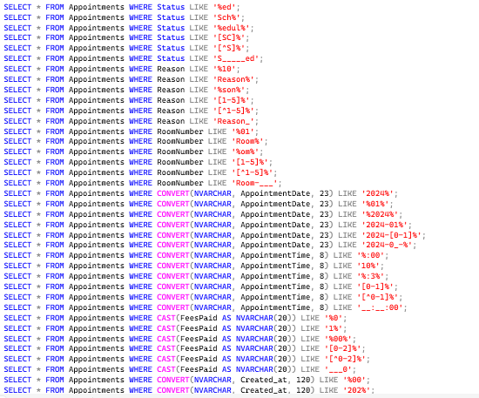
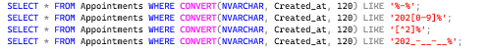
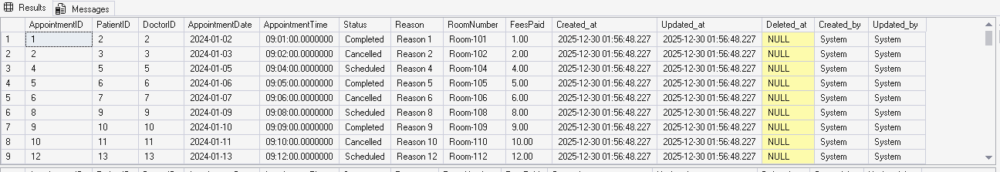

Staffs:
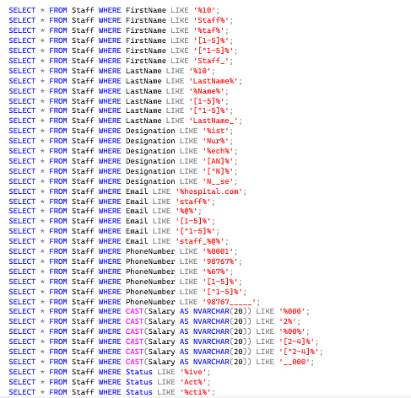
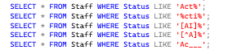
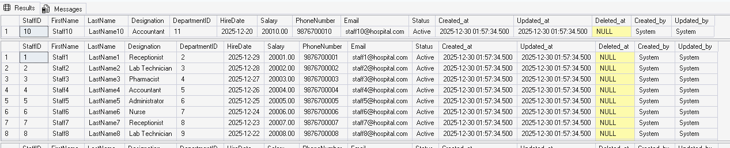

Medicines:
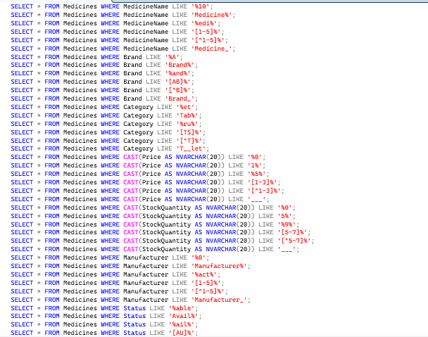
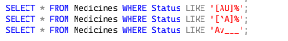
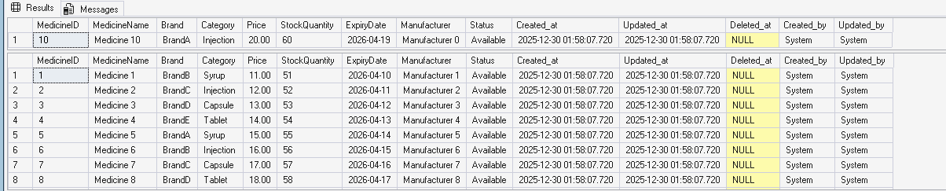

Bills:
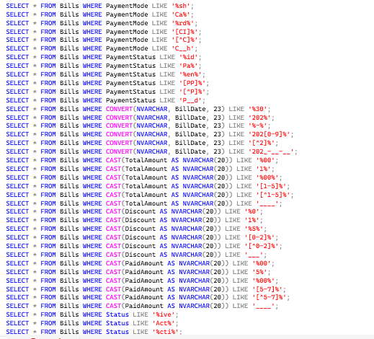
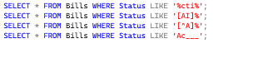
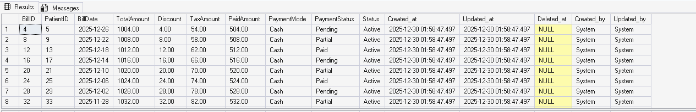

Rooms:
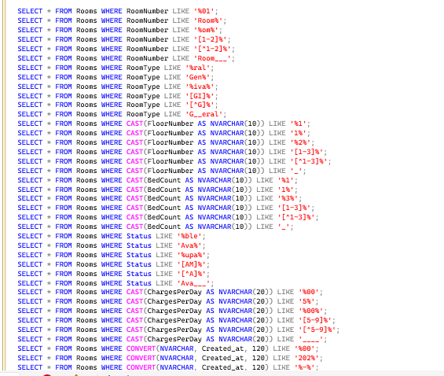
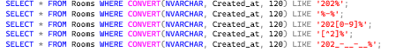
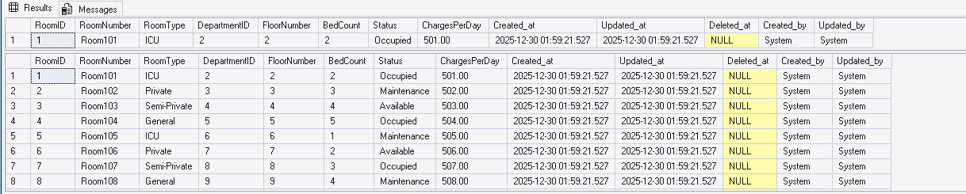

Departments:
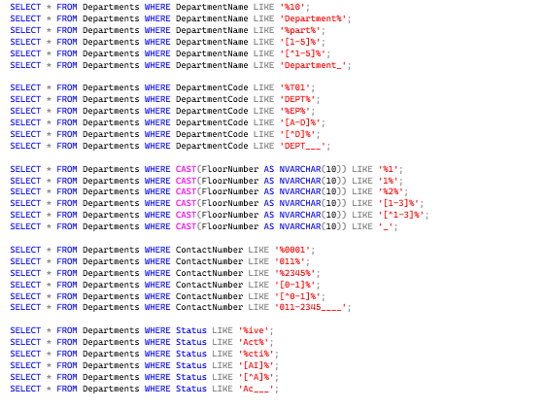

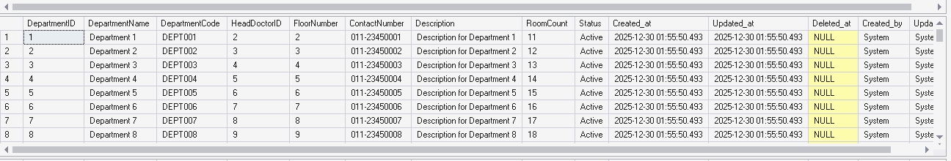

Lab Reports:
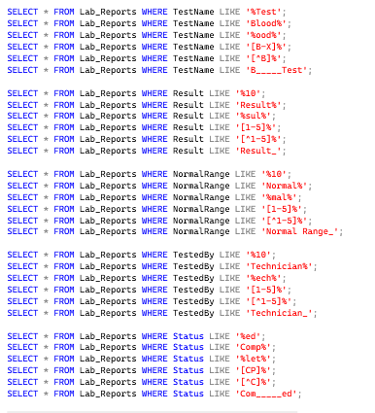
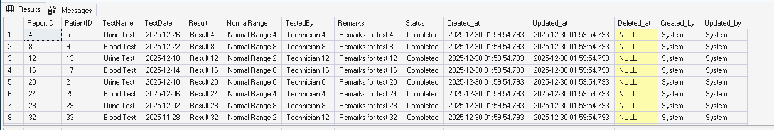

Prescriptions:
